EXPERIMENT – 8

EXP No: 8

Date: ___________

Title
Subqueries and Correlated Subqueries

AIM
To perform Subqueries and Correlated Subqueries on the Drone Delivery Management System database.

DESCRIPTION
A Subquery is a query inside another SQL query. A Correlated Subquery depends on the outer query and executes once for every row processed by the outer query.

PROCEDURE
- Open MySQL Command Line.
- Select the DroneDelivery database.
- Execute Subqueries.
- Execute Correlated Subqueries.
- Display the results.

Query 1

USE DroneDelivery;



Query 2

SELECT *

FROM Drones

WHERE PayloadCapacity=

(

SELECT MAX(PayloadCapacity)

FROM Drones

);

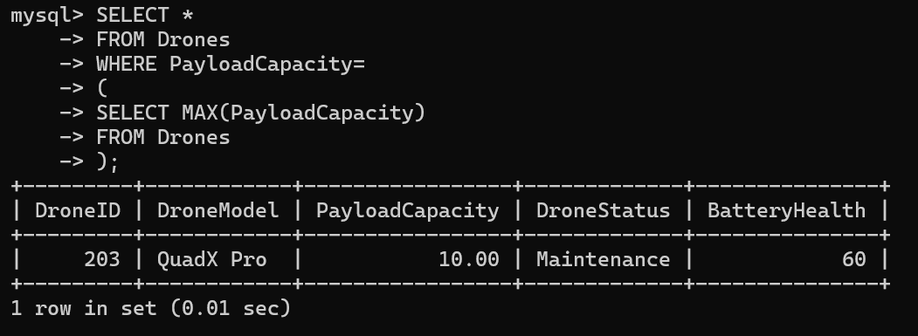

Query 3

SELECT *

FROM Customers

WHERE CustomerID=

(

SELECT CustomerID

FROM Deliveries

WHERE DroneID=201

);

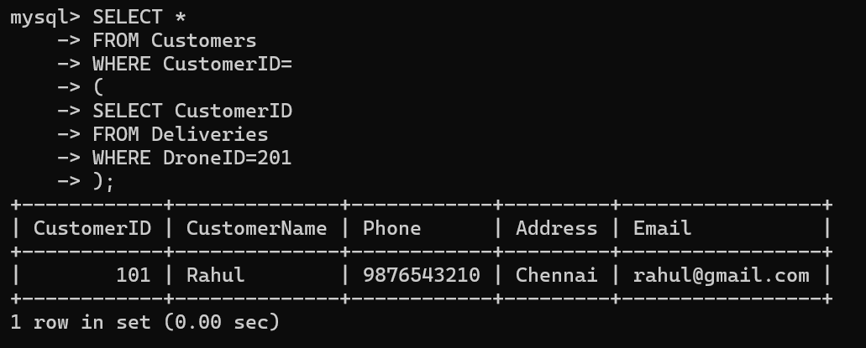

Query 4

SELECT *

FROM Deliveries

WHERE DeliveryID=

(

SELECT MAX(DeliveryID)

FROM Deliveries

);

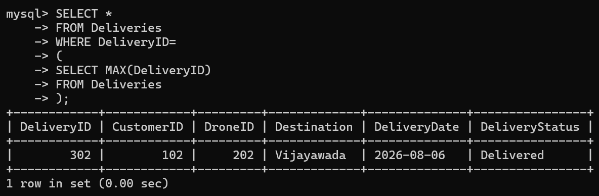

Query 5

SELECT *

FROM Drones

WHERE PayloadCapacity >

(

SELECT AVG(PayloadCapacity)

FROM Drones

);

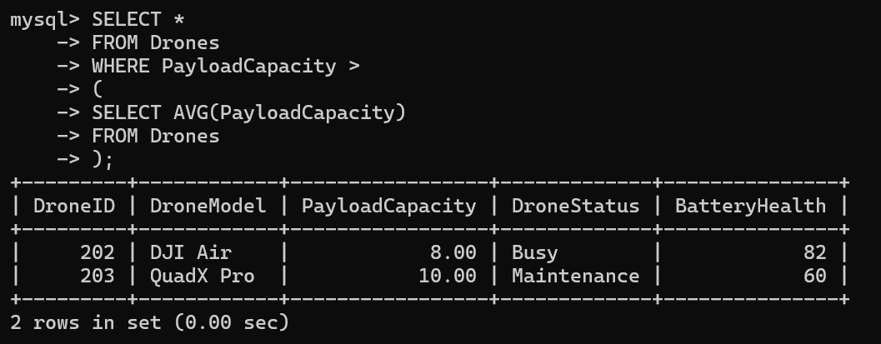

Query 6

SELECT *

FROM Customers C

WHERE EXISTS

(

SELECT *

FROM Deliveries D

WHERE D.CustomerID=C.CustomerID

);

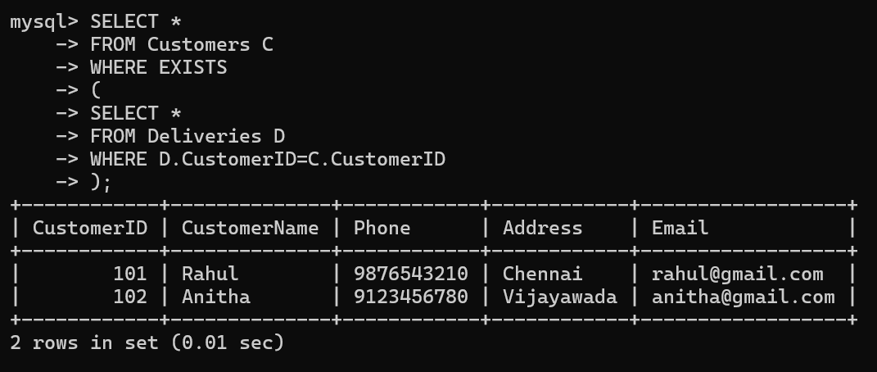

Query 7

SELECT CustomerName

FROM Customers

WHERE CustomerID IN

(

SELECT CustomerID

FROM Deliveries

WHERE DeliveryStatus='Delivered'

);

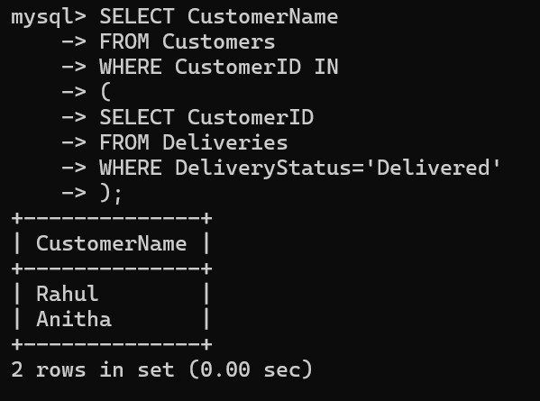

Query 8

SELECT *

FROM Drones

WHERE PayloadCapacity=

(

SELECT MIN(PayloadCapacity)

FROM Drones

);

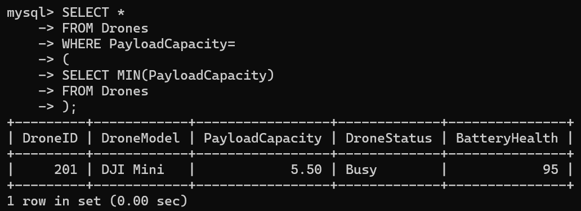

Query 9

SELECT Destination

FROM Deliveries

WHERE DeliveryDate=

(

SELECT MAX(DeliveryDate)

FROM Deliveries

);

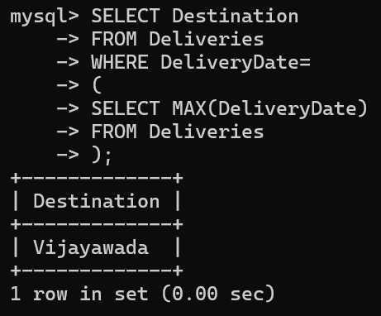

Query 10
SELECT DroneModel
FROM Drones
WHERE DroneID=
(
SELECT DroneID
FROM Deliveries
WHERE DeliveryID=301
);

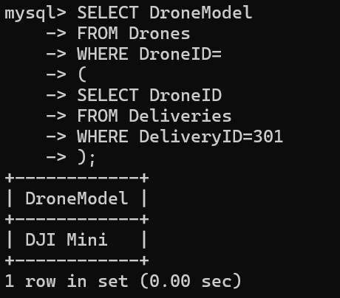
RESULT
Thus, Subqueries and Correlated Subqueries were successfully executed on the Drone Delivery Management System database.

